**Group Project - Use Cases**

**Hadi, Zack, and Greg**

**Use Case #1 – Add a Course**

1. Click on ‘Add a Course’ Link.

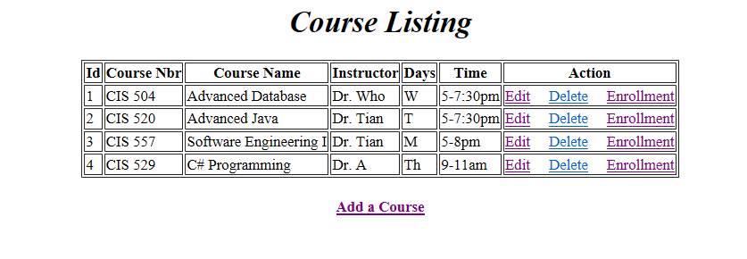

1. Fill out Course Details and press ‘Save’ button.

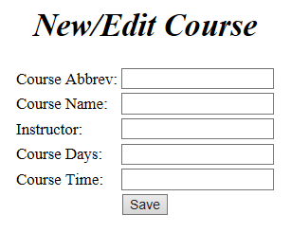

**Use Case #2 – Edit a course**

1. From the ‘Course Listing’ screen, click the ‘Edit’ link on a course.
2. Modify Course Details and press ‘Save’ button.

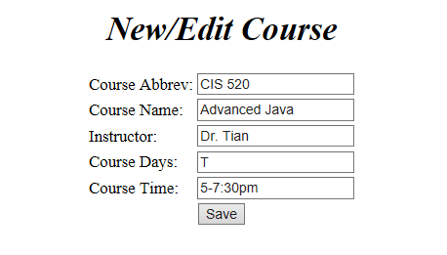

**Use Case #3 – Delete a course**

1. From the ‘Course Listing’ screen, click the ‘Delete’ link on a course.

**Use Case #4 – Add a student to a course**

1. From the ‘Course Listing’ screen, click the ‘Enrollment’ link on a course.

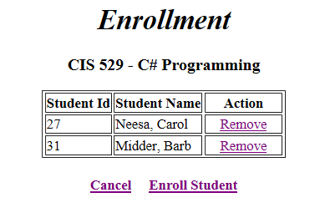

1. Click on ‘Enroll Student’ Link.

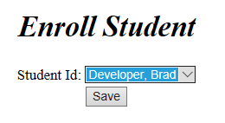

1. Select a student from the drop down and click the ‘Save’ button.

**Use Case #5 – Remove a student from a course**

1. From the ‘Course Listing’ screen, click the ‘Enrollment’ link on a course.
2. Click the ‘Remove’ link on a student.

